Perfect espresso. Handmade, automatically

WMF espresso ushers in a new era for portafilters

Those who seek the perfection of full automation with the coffee culture of a portafilter will immediately find what they are looking for with WMF. Pioneering an entirely new machine era, the WMF espresso represents a revolutionary type of coffee-making. Even with little technical know-how, users can now make the perfect espresso and café crème. The whole process is characterised by complete reliability and constantly high coffee quality – without time-consuming and costly training. All potential sources of error in the manual preparation of coffee specialities have now been eliminated by WMF engineers and replaced by automatic processes. The result: traditional coffee culture at the touch of a button. The clear lines and timeless design of the WMF espresso, winner of the 2015 iF Design Award, underscore this aspiration.

Reliable barista skills
The traditional portafilter is a symbol of traditional coffee enjoyment. Although loved by many restaurant owners, it is labour-intensive and training costs are high. If they skimp on this investment, operating errors can occur. WMF has used its technological know-how to develop a portafilter that is reliable and also guarantees emotional barista competence. "Service staff continue to work in the traditional way front of house, where it is important to have the hiss and steam. But the machine now takes over at those points where errors often occur – grinding and dispensing the right amount of coffee or tamping with just the right amount of pressure," explains Melanie Nolte, Head of Marketing at WMF Coffee Machines, the patented technology of WMF espresso.

Anyone can be a barista!
Fitted with an intuitive touch display, the WMF espresso guides users through all steps of coffee preparation. When a customer orders a drink, the operator inserts the single or double dispenser portafilter in the brewing group. Automatic portafilter recognition prevents the operator from using the wrong dispenser. The operator then takes a warm cup from the push-in, heated cup storage rack directly above the two air-cooled bean hoppers for espresso and/or café crème. Specially designed for espresso cups, the integrated steam jet function allows additional preheating using directed steam.

Once the cup has been placed on the folding cup tray, the user chooses the coffee product ordered (up to 12 varieties) by pressing the product button. The selected drink will now be prepared with the temperature stored in the recipe – fresh and fully automated. Another plus is the special button for each brew group, which allows more types of coffee to be added for external grinding. There is also a barista button, which varies the weighing of coffee grounds by 15%. This allows operators to adjust coffee strength to individual customer preferences. Once the delicious piping hot espresso or café crème is in the cup, the operator knocks the portafilter in the tried and tested manner over the grounds container.

Making milk foam is also child's play with the new WMF espresso: along with a traditional manual steam spout, the machine also has an "auto steam" function, which automatically produces hot milk and milk foam in up to three different consistencies. This ensures process reliability and the highest milk foam quality.

For lovers of fine tea, the WMF espresso has a separate hot water spout for different cup sizes.

Last but not least
WMF espresso also benefits from the long-standing coffee expertise of Geislinger engineers in terms of care and maintenance. The fully automated cleaning of the coffee-dispensing parts is done using a blind filter and tablet; a separate drip tray ensures efficient cleaning in the dishwasher.

Photo request
You can see images on our media portal at http://press-n-relations.amid-pr.com (search for „WMFespresso“). We will also be pleased to send you this file by e-mail on request. Contact: wmf@press-n-relations.de.

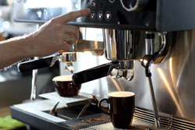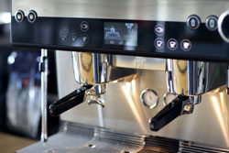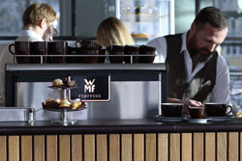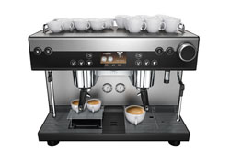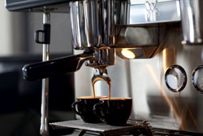

Additional information:  WMF Group GmbH  Luise Glauert  Corporate Communications  Eberhardstraße 35 – D-73309 Geislingen  Tel.: +49 73 31 25 8153  Fax: +49 73 31 25 8061  luise.glauert@wmf-group.com - www.wmf.de | Press and public relations  WMF press agency  c/o Press’n’Relations GmbH  Monika Nyendick  Magirusstrasse 33 – D-89077 Ulm, Germany  Tel.: +49 731 96287-30  Fax: +49 731 96287-97  wmf@press-n-relations.de  www.press-n-relations.de

About the WMF Group
For more than 160 years, the brands that make up the WMF Group have represented the best in cooking, drinking and dining. Every day, several 100 million people around the world use WMF, Silit and Kaiser products to prepare food, cook, bake, eat and drink in the comfort of their own home. And when they are not doing that, they are enjoying coffee specialities and dishes prepared in hotels and restaurants using products made by WMF, Schaerer and HEPP. Our employees are passionate about bringing people together, whether at home, on the move or at high-end restaurants, in order to give them shared moments that are both precious and tasty. This is all possible thanks to our products, whose exceptional design, perfect functionality and highest quality provide wonderful culinary experiences. Our company has a proud tradition, and was founded in Geislingen an der Steige in Germany back in 1853. Almost 6,000 employees provide culinary joy at more than 40 locations worldwide. Since the end of 2016, WMF Group is part of Groupe SEB.

