Darmstadt, October 13, 2017
AKASOL at Busworld Europe: Hall 9, Booth 910A
Akasol shows next generation high-performance battery systems for e-buses
The AKASYSTEM OEM system is cost-effective, efficient, and will be used by two European bus manufacturers from next year
At Busworld Europe (Kortrijk, October 20–25, 2017) AKASOL will present its AKASYSTEM OEM battery system as a complete roof installation including the chiller and other additional components. This system has allowed AKASOL to be very successful in the market for electric and hybrid buses. From 2018, two well-known European bus manufacturers will using the technology in Germany, with plans to equip around 10,000 e-buses over the next few years. AKASOL is now expanding its production facilities in order to meet growing demand and further customer orders.
With its compact dimensions (150 x 700 x 1,700 mm) and modular design, AKASYSTEM OEM is especially suitable for use in commercial vehicles such as buses or trucks. AKASOL has succeeded in integrating standardized PHEV battery modules (plug-in hybrid electric vehicle) from major manufacturers which are also used in the passenger car segment. “This fact alone is reflected in an economically attractive price-performance ratio,” says Sven Schulz, CEO of AKASOL. “Our customers also benefit from the economies of scale resulting from our serial production supply to various OEMs for electrically powered buses and trucks, as well as construction and special vehicles.”
Sustainability and safety in serial production
Developed in accordance with the ISO 26262 standard, AKASYSTEM OEM can be adapted to match specific customer requirements, making it fully scalable. With a novel, cost-effective water/glycol cooling system, it is especially efficient and durable. In day-to day use, for example in public transport, this results in optimal thermal environmental conditions. The lithium-ion battery system achieves more than 3,000 full cycles and can be fast-charged with up to 500 kilowatts.
The standard version of AKASYSTEM OEM has a storage capacity of 24.4 kWh at a voltage of 661 V (nominal) and achieves an output of 150 kWp. Energy amount and power can be scaled up to virtually any level by connecting an unlimited number of AKASYSTEM OEM units in parallel. The system also complies with the highest safety standards in the automotive sector, such as the Automotive Safety Integrity Level ASIL-C, as well as all EUCAR, GB/T, UN 38.3, and ECE R100 safety and performance requirements.
Expanding production facilities
AKASOL will shortly put two further production sites with more than 3,700 square metres of additional hall and office space into operation. In the first phase of expansion, the company will start large-scale production of battery systems for electric buses with a capacity of up to 300 MWh at a new facilitiy in Langen. This means that between 1,000 (300 kWh) and 1,500 (200 kWh) electric buses can be equipped each year. In the second step, the capacity is to be expanded to 600 MWh per year (2,000 to 3,000 buses). The automated, automotive-suitable serial production line, which is certified according to IATF 16949, will be commissioned in November.

Images
(AKA_E-Bus_DAM1931.jpg)
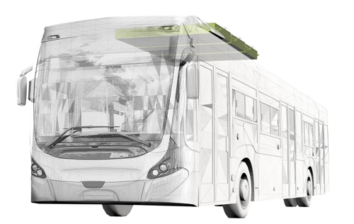
AKASOL’s high-performance battery systems allow versatile positioning
depending on the model of bus. (Graphic: AKASOL)

AKA_AKASYSTEM-OEM-3B.jpg, AKA_AKASYSTEM-OEM-6B.jpg
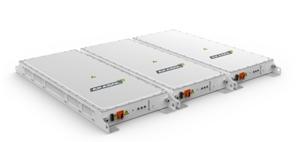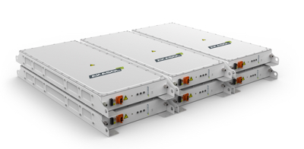
Meeting every specification profile – the AKASYSTEM OEM battery trays can be connected in parallel or in series, depending on system requirements. (Graphic: AKASOL)

Further information  AKASOL GmbH, Katja Steinhauser  Landwehrstraße 55, 64293 Darmstadt, Germany  phone.: +49 6151 80 05 00-140  fax: +49 6151 80 08 00-129  katja.steinhauser@akasol.com  www.akasol.com | Press and public relations:  Press’n’Relations GmbH, Uwe Taeger  Magirusstraße 33, 89077 Ulm, Germany  phone.: +49 731 96 287-31  fax: +49 731 96 287-97  ut@press-n-relations.de  www.press-n-relations.de
About AKASOL
AKASOL GmbH has developed and manufactured mobile and stationary high-performance battery systems for the German and European market for 25 years. Its multi-award-winning storage solutions are used primarily in the automotive and commercial vehicle industries, the off-highway industry, and the solar power and wind power sectors.

