Geislingen, 30. September 2015

host – international hospitality exhibition - 23. to 27. October 2015, fieramilano,
Hall 15P, Stand A68-B67

All of the coffee your heart desires

WMF will spoil HoReCa professionals with moments of premium pleasure at host 2015

At this year's host in Milan – the international trade fair hotspot of the hotel, restaurant and catering sector – the Geislingen-based premium manufacturer WMF will present its innovative coffee expertise. The WMF 5000 S fully automatic coffee machine, the WMF Dynamic Milk system and the WMF espresso portafilter concept will be taking centre stage.

Coffee to go, go, go!
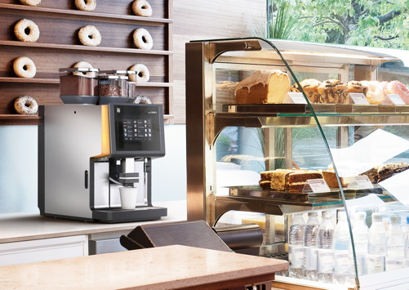
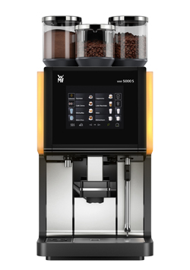
The new WMF 5000 S will be one of the absolute highlights of the trade fair, a speciality machine that delivers up to 250 cups per hour, even in very small spaces. With three large combinable, lockable product containers with capacities ranging from 550 to 1,200 grams for coffee beans, toppings and chocolate, the fully automatic machine satisfies every customer's desires. For ease of use, both of the high-performance grinders have been decoupled from the housing, which means that the grinding process takes place quietly and, above all, quickly. In addition, an eight-inch man-machine interface (MMI) touch display intuitively guides the user through all of the functions of the WMF 5000 S. These include flexible recipe generation and definition of time-controlled operating profiles, such as automatically changing from fresh milk to toppings or varying the range of drinks. Different key layouts allow for individual customisation of the user interface according to the area of application – from colours and backgrounds, to the quantity and arrangement of the keys, to pictures of drinks. What's more, the WMF 5000 S offers an entire range of intelligent self-service highlights, which can be effortlessly configured using the touch display. This also includes the option of menu-based retrieval of drinks options using "PostSelection". The machine guides the guest through the preparation options step by step, before preparing the desired drink, fully automatically. In order to shorten the wait and to draw attention to attractive additional offers, the preparation time can be used to show advertisements on the display.

Luxurious froth thanks to the WMF Dynamic Milk
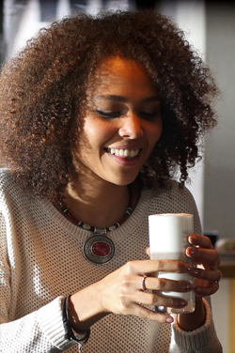
There is also something for the milk artists among the HoReCa professionals with the new WMF 5000 S. Alongside the "Easy Milk" option for the preparation of hot milk froth as well as hot and cold milk, the fully automatic machine can also be equipped with the new "Dynamic Milk" system. The pump system, which conforms to HACCP, caters to every taste with four different consistencies for hot creations (liquid, creamy, firm and airy) and three options for milk-based speciality coffees (liquid, creamy, firm) with cold froth. Depending on the desired temperature, firmness and porosity, the beverage is made up of between 60 to 90 per cent froth. Steam heating, in keeping with the traditional barista method, ensures that the intense milk flavour is fully preserved in every consistency of froth. The cleaning process of the WMF Dynamic Milk will also impress users from start to finish. The new "Clean in Place" method guarantees time-saving, HACCP-compliant cleaning, during which the milk frother remains in the unit and no longer needs to be removed. The new milk system is also available for the "little brother" of the WMF 5000 S, the fully automatic WMF 1500 S, which has a capacity of up to 180 cups.

Everyone can be a barista: perfect espresso, automatically crafted
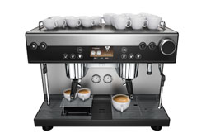
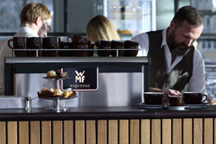
Anyone who seeks to combine the perfect results and operating speed of a WMF fully automatic machine with the emotional aspects of traditional coffee culture will find the ideal coffee concept in the fully automatic "WMF espresso" portafilter. Pioneering a new machine era, it represents a revolutionary type of coffee-making. Every user succeeds in creating barista-quality espresso and café crème at the first go. The secret: all of the usually manual steps are carried out fully automatically with the WMF espresso. Service staff continue to work in the traditional way front of house, where it is important to have the hiss and steam. In this way, the whole preparation process of the coffee is characterised by high process stability and speed. Lengthy and costly training courses are things of the past. The user inserts the portafilter into the machine and selects the desired drink – that's it. Frothing milk at the same time is also child's play with the new WMF espresso. Along with a traditional manual steam wand, the machine also has an "auto steam" function, which automatically produces hot milk and milk froth in up to three different consistencies.

Photo request
You can see images on our media portal at http://press-n-relations.amid-pr.com (search for „WMF-HOST-2015 “). We will also be pleased to send you this file by e-mail on request. Contact: wmf@press-n-relations.de.

At this year's host in Milan – the international trade fair hotspot of the hotel, restaurant and catering sector – WMF will present its innovative coffee expertise.
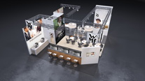

Additional information:  WMF Group GmbH  Thomas Dix, press spokesman  Eberhardstraße - 73309 Geislingen  Tel.: +49 73 31 25 8386  Fax: +49 73 31 25 8061  thomas.dix@wmf.de  www.wmf.de | Press and public relations  WMF press agency  c/o Press’n’Relations GmbH  Monika Nyendick  Magirusstrasse 33 – D-89077 Ulm, Germany  Tel.: +49 731 96287-30  Fax: +49 731 96287-97  wmf@press-n-relations.de  www.press-n-relations.de

About WMF Group
The WMF Group GmbH, located in Geislingen/Steige, is one of the leading premium manufacturers of cutlery, tableware and kitchen products as well as professional coffee machines. The Group offers its customers high-quality, innovative products that are distinguished by their sophisticated design and outstanding functionality. The company sets standards with its many innovations and is an important source of inspiration within the market. It is an organisation with a long tradition, having been founded in 1853 and now operates on an international scale with 6,000 employees at more than 40 locations. With its brands Boehringer Gastro Profi GmbH, Hepp, Kaiser, Schaerer, Silit und WMF the company generated a turnover of 1,024 million euros during the financial year 2014.

