Schaerer Coffee Prime Brew:
The new and economical way of brewing freshly ground filter coffee

Zuchwil, 29.07.2015 – The new Schaerer Coffee Prime Brew from established Swiss coffee machine manufacturer Schaerer has been developed especially for preparing and brewing freshly ground coffee. Whether the breakfast service in a hotel or community catering in companies or hospitals – the fully automated coffee machine is in demand anywhere where larger quantities of top quality fresh filter coffee is being offered with a speedy preparation time at the touch of a button. In addition, the coffee machine allows smaller quantities to be programmed, for example a cup, a pot or small pot, and also brews tasty coffee of the highest standard at less high-turnover times. This flexibility results in a consistently high quality of the beverages as it's no longer necessary to maintain a supply of ready-to-go coffee. This also makes coffee preparation on demand more economic for the organisation. The Schaerer Coffee Prime Brew is available from October 2015 and thanks to its design based on the tried and tested Schaerer Coffee Prime, it represents the perfect visual complement to this speciality coffee machine.

With the development of the Coffee Prime Brew, Schaerer is for the first time launching onto the market a coffee machine for the fully automated preparation of freshly ground filter coffee. "The requirement for high quality, fresh filter coffee has risen once again in many sectors and target groups – both nationally and internationally. We are set to meet this trend with the new Coffee Prime Brew from Schaerer and are expanding our product range to meet the requirements of the market", according to Inga Schäper, Head of Marketing & Coffee Competence Centre at Schaerer AG. The coffee machine incorporates tried and trusted Schaerer technology designed with a newly developed brewing unit precisely for the perfect preparation of larger quantities of coffee. "The best possible brewing quality is achieved thanks to the perfect coordination of all parameters relating to the preparation process and not least thanks to the fresh ground roasted coffee instead of storing pre-ground coffee," explains Schäper. Another bonus for coffee quality and taste: The Coffee Prime Brew prepares different reference quantities at the touch of a button, meaning that the coffee can always be provided in the exact amount needed. It is not necessary to pre-heat and keep the beverages warm for extended periods.

At peak times, the Coffee Prime Brew brews 500 ml of coffee per minute; meaning that up to 30 litres can be dispensed in one hour. The recipe for this as well as for smaller quantities, such as pots or small pots, can be freely programmed and stored by the operator. Thanks to its ease-of-use via the TouchIT 7" touchscreen control panel, the stored reference values can be easily retrieved by any service staff member. The Coffee Prime Brew also impresses with ease-of-use – for example, unlike with ground coffee for standard filter coffee machines, the beans don't need to be topped up before each brewing process and with a countertop grounds chute, there is no work required to dispose of the grounds. The Coffee Prime Brew also scores highly in terms of cost-effectiveness: Thanks to the flexibility in the reference sizes, beverages can be freshly brewed – this minimises the amount of unused coffee discarded. In addition, unlike with filter machines, no paper filters are required. Last but not least, the Coffee Prime Brew switches to standby mode when not in use, thus reducing energy costs.

Attractive overall package
In other respects the new coffee machine also provides everything required for smooth-running coffee supply: With its compact dimensions of 380mm width (490 mm with brewing arm extended), 598 mm depth and 570 mm height, it can be fitted almost anywhere and also looks great when paired with the Schaerer Coffee Prime. Its modular design with numerous expansion options – from the cup warmer to the connection to different payment systems – allows the Coffee Prime Brew to grow with the requirements of the operator. In the standard version, the coffee machine includes a grinder with lockable bean hopper for 600 grams of coffee beans. As an option, the version with just one grinder has a bean hopper for 1200 grammes of coffee beans. In addition, the Coffee Prime Brew can be equipped with a second grinder. For can filling, the brewing arm can be swung out sideways, the maximum discharge height is 450 mm. Large or small pots are filled from the double outlet with a maximum height of 180 mm that can be adjusted using the swivelling cup tray.

Cleaning and hygiene
The Coffee Prime Brew offers a fully automatic cleaning programme that is used to clean the components conveying water and coffee to ensure consistently high beverage quality. For a hygienic working method during ongoing operation, the automatic, interval-controlled brewer rinsing and the large coffee grounds container with optional counter grounds chute or further base options.

Image material
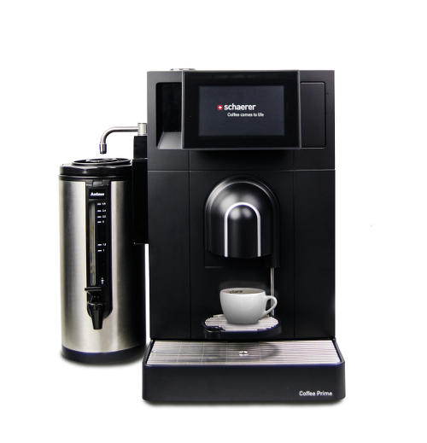 | The Schaerer Coffee Prime Brew provides variable quantities of high quality brewed coffee.

Image requirements
Image material for download can be found in our media portal press-n-relations.amid-pr.com (search term "Schaerer Coffee Prime Brew"). Naturally I would be happy to send you the files via email as well. Contact: nforstner@press-n-relations.ch

More information:  Schaerer AG, Inga Schäper  Allmendweg 8, 4528 Zuchwil  Tel.: +41 32 681 64 01  Fax: +41 32 681 64 04  inga.schaeper@schaerer.com  www.schaerer.com | Press and PR work:  Schaerer AG Press Office  c/o Press'n'Relations GmbH, Nataša Forstner  Hirslanderstr. 51, 8032 Zürich  Tel.: +41 43 344 58 65  Fax: +41 43 344 58 69  nforstner@press-n-relations.ch  www.press-n-relations.ch

Schaerer AG
Schaerer AG, headquartered in Zuchwil near Solothurn, Switzerland, was founded in 1892 and is one of the world's leading manufacturers of fully automatic professional coffee machines, offering the perfect solution for every need and service requirement. Schaerer AG has an international presence with subsidiaries in Germany, Belgium and the USA and with over 70 partners on every continent. Customers around the world appreciate the ease-of-use, wide range of beverages at the touch of a button and the outstanding coffee quality. Numerous innovations, including the revolutionary, Best Foam milk system patented by Schaerer underline the company's pioneering spirit. The company's strapline "Coffee comes to life" stands for the enjoyment of coffee that moves people. With the "Barista inside" slogan, Schaerer combines coffee machine technology and many years of coffee expertise with the craftsmanship of a barista: On the inside of the coffee machines, all the details are perfectly coordinated to prepare beverages that are equal in taste and appearance to the coffee creations handcrafted by baristas.

