Mobile coffee concepts for catering events, conferences and the like:
Variety and quality at the press of a button instead of Thermoses and coffee cream

Zuchwil, 09/06/2015 – Meetings, workshops and seminars without coffee? Unthinkable! Whether during a break or for a caffeine kick during a meeting - you need hot coffee. Traditional Swiss coffee machine maker Schaerer introduces new quality and versatility to the coffee catering of events, conferences and the like with its mobile coffee concepts. For high-quality coffee specialities at events or directly in front of the conference room, Schaerer offers its full coffee machines, such as Schaerer Coffee Prime or Schaerer Coffee Art Plus, together with a compact and stylish trolley. The trolley can be customized to fulfil different customer requirements - including an integrated water tank and refrigerator.

"Our mobile coffee concepts give hotels, convention centres and catering operations as well as companies the chance to offer their guests high-quality coffee specialities during meetings, conferences or events", says Markus Andres, Head of Swiss Sales at Schaerer AG. Although fully automated coffee machines have long provided a variety of coffee and milk specialities at the press of a button in office kitchens and restaurants, Thermoses and coffee cream are often still found on the table of conference rooms. The mobile coffee concept from Schaerer can change this: Directly on a trolley or placed in a conference room, a full coffee machine can offer participants the hot drink they want. This investment pays for itself in many ways: On the one hand, it is a clear statement about high quality and regard for your guests. "The 'Barista inside' spoils them with freshly prepared hot drinks directly in the meeting area. On the other hand, coffee and milk drinks are very popular and coffee sales can be increased. Billing is done in line with consumption. Another advantage is flexible use: The coffee bar can be rolled to wherever it's needed. An unused coffee machine in the lobby or one only used during the lunch break in the company restaurant is a thing of the past.

Perfect combination of coffee machine and trolley
Based on the requirements such as location, type of use or capacity, Schaerer can recommend the suitable full coffee machine and the matching trolley equipment. For conferences with up to 60 participants, the Schaerer Coffee Prime is an excellent choice. Designed for self-service, it scores points with its compact dimensions and a wide variety of products. In addition, the model can be equipped with a cooling unit for fresh milk or a cup dispenser including sugar packets as well as stirrers and offers everything you need for providing coffee. The trolley does the rest - a refrigerator and an external drinking water tank can be integrated depending on the requirements. In addition, a second tank is connected for the residual water created when making coffee. And the Schaerer Coffee Prime also sets the bar very high when it comes to cleaning efficiency. The ecological disposable NcFoamer system is a particular highlight. Instead of elaborate cleaning of the milk-dispensing components, they are simply replaced.

The Schaerer Coffee Art Plus can also be customised for mobile coffee catering and is well-suited for up to 250 cups per hour and up to 250 participants with a fast output, for example during breaks in conferences or other events. It can make all kinds of coffee and milk drinks, participants get a perfect Cappuccino or Latte Macchiato. A practical marketing option with both machines: The company logo, individual greeting or motto of the event, etc. can be printed on the display according the individual specifications of the organizers.

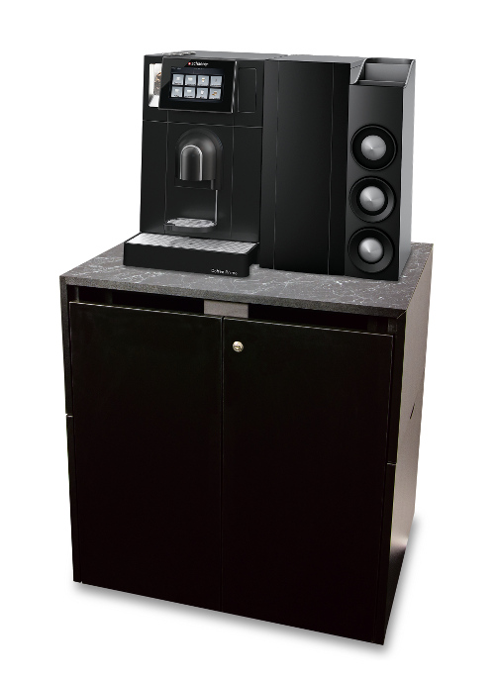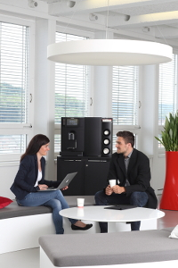

The Schaerer Coffee Prime is perfectly suited for mobile coffee supply.

Image availability
You can find downloadable image material on our media portal press-n-relations.amid-pr.com (search term "Schaerer Mobile Coffee Concepts CH"). Please use only this images for Switzerland. Of course, I would also be happy to send you the files by e-mail. Contact: nforstner@press-n-relations.ch

Further information:  Schaerer AG, Inga Schäper  Allmendweg 8, 4528 Zuchwil  Phone: +41 32 681 64 01  Fax: +41 32 681 64 04  inga.schaeper@schaerer.com  www.schaerer.com | Press and public relations:  Press'n'Relations GmbH, Nataša Forstner  Hirslanderstr. 51, 8032 Zurich, Switzerland  Phone: +41 43 344 58 65  Fax: +41 43 344 58 69  nforstner@press-n-relations.ch  www.press-n-relations.ch

Schaerer AG
Schaerer AG, founded in 1892 and headquartered in Zuchwil, close to Solothurn, Switzerland, is one of the world's leading manufacturers of fully automatic restaurant coffee machines and can provide the right solution for any feature or performance requirement. Customers all over the world value Schaerer products for their ease of use, the large selection of beverages available at the push of a button, and the excellent coffee quality. As the inventor of the fully automated cappuccino system, the long-established Swiss company also positioned itself as the innovation leader in the area of milk solutions in 1997. Schaerer AG is internationally represented by subsidiaries in Germany, Belgium and the USA and by over 70 partners around the world.

