host – The international trade fair for professional hospitality
23–27 October 2015, Fiera Milano, Hall 15, Booth C68 D67

With "Best Foam", "M2M Coffee Link" and "Coffee Prime Brew", Schaerer is presenting three product innovations at once at host 2015 in Milan

At host in Milan, the international trade fair for professional hospitality, traditional Swiss coffee machine manufacturer Schaerer is spotlighting three product innovations: The revolutionary patented Best Foam milk system for barista-level coffee beverages, the new Schaerer "M2M Coffee Link" telemetry solution for real-time communication between the coffee machine and central management system as well as the Schaerer Coffee Prime Brew coffee machine for fully-automated preparation of brewed coffee from freshly-ground coffee beans. The Schaerer trade fair booth is located in Hall 15, Booth C68 D67.

Best Foam – The revolutionary patented milk system
With its new Best Foam milk system, Schaerer is introducing an innovative technology for the preparation of barista-quality milk foam. In next to no time, customers get an exquisite cappuccino with the characteristically dark espresso ring as well as an outstanding "Fujiyama" cappuccino with a particularly tall bonnet of milk foam. Those who like things a bit more extravagant can serve a "Atoll" chociatto or white americano macchiato. And for the kids, the aromatic cold-milk creations with fluffy, scoopable foam are an another appealing selection. Thanks to the "easy setting" principle, the system provides excellent milk foam options with no trouble at all for any desired recipe. From international trends and customer taste preferences to in-house creations: This means that restaurateurs can store individual settings for the perfect milk foam consistency – from very liquid to firm – as well as an ideal milk temperature. At the push of a button, the selected coffee product is prepared with a consistent appearance, unwavering taste and the perfect symbiosis of cream and milk foam. This concept has enabled Schaerer to perfect the fully automated preparation of individual milk-based coffee creations that live up to its "Barista inside" motto. The Best Foam milk system is available for the Schaerer Coffee Art Plus.

"M2M Coffee Link" – Telemetry solution for data transmission in real-time
Rather than rely on standard solutions from third-party providers, Schaerer collaborated with strong partners to develop its own telemetry solution for data transmission in real-time from the coffee machine to external locations and will present it live at host 2015. Compared to standard solutions, the new development "Schaerer M2M Coffee Link" offers considerable advantages to customers and service partners: "M2M Coffee Link" and Schaerer coffee machines work together perfectly. The telemetry solution is designed precisely to the software of these fully automatic coffee machines and thus quickly supplies reliable data. The software connection gives restaurant owners, operators and service providers new options for efficiently monitoring, controlling and optimising business-related and service-related processes. For example, detailed sales data allow better monitoring and transparency of accounting matters across one or more locations. Information on filling levels and consumption can be used to optimise product supply, preventing downtime and decreases in sales in coffee machines operated in self-service mode, for example. In terms of regular maintenance, "M2M Coffee Link" enables use-based planning of maintenance intervals, meaning that coffee machines are maintained based on their use levels and not on a fixed time interval. This reduces maintenance costs while also protecting against malfunctions and downtimes. Based on data transmitted to show the current state of the coffee machine, service providers can respond to malfunctions promptly. As "Swiss software", the Schaerer telemetry solution with certified hosting in Switzerland and encrypted data transmission meets the highest security standards.

Schaerer Coffee Prime Brew – Brewed coffee from freshly-ground coffee beans
With the development of the Coffee Prime Brew, Schaerer is launching the first coffee machine for fully-automated preparation of freshly-ground brewed coffee on the market. The coffee machine features seasoned Schaerer technology which, with a newly-developed brewing unit, is designed precisely for the optimal preparation of large amounts of coffee. Be it the breakfast service at a hotel or mass catering in a company or hospital – The fully-automated coffee machine stands up to the test wherever large amounts of fresh filter coffee of the highest quality must be prepared in a short amount of time and at the press of a button. In addition, the coffee machine enables the programming of small quantities, for example for a small cup, a large cup or a small pot, and brews tasty, highest-quality coffee at less-frequented times. This flexibility results in consistently high-quality beverages, since the finished coffee is not left sitting for long periods of time. The Coffee Prime Brew also impresses with its easy operation. For example, compared to ground coffee in conventional filter coffee machines, the beans do not have to be filled before every brew, and with the countertop grounds chute, there is no work required to dispose of the grounds. The Coffee Prime Brew also shines when it comes to cost-effectiveness: Due to the flexibility of the reference sizes, coffee can be brewed according to the current needs – Less unused coffee is thrown out. Last but not least, since the design of the Schaerer Coffee Prime Brew is based on that of the Schaerer Coffee Prime, it is also the perfect aesthetic complement to this speciality coffee machine.

Image material:

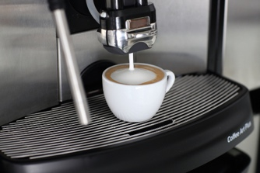 | 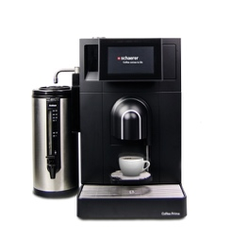 | 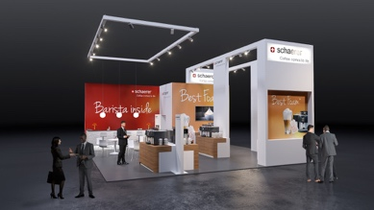
Best Foam provides outstanding barista-level milk foam quality. | The Schaerer Coffee Prime makes brewed coffee in different quantities. | Schaerer is spotlighting three product innovations at the host trade fair in Milan.

Image availability
You can find downloadable image material on our media portal press-n-relations.amid-pr.com (search terms "Schaerer Best Foam", "Schaerer Coffee Prime" and "Schaerer trade fair booth host"). Of course, I would also be happy to send you the files by e-mail. Contact: nforstner@press-n-relations.ch

Further information:  Schaerer AG, Inga Schäper  Allmendweg 8, 4528 Zuchwil, Switzerland  Tel.: +41 32 681 64 01  Fax: +41 32 681 64 04  inga.schaeper@schaerer.com  www.schaerer.com | Press and public relations:  Schaerer AG Press Office  c/o Press'n'Relations GmbH, Nataša Forstner  Hirslanderstr. 51, 8032 Zurich, Switzerland  Tel.: +41 43 344 58 65  Fax: +41 43 344 58 69  nforstner@press-n-relations.ch  www.press-n-relations.ch

Schaerer AG
Founded in 1892 and headquartered in Zuchwil, near Solothurn, Switzerland, Schaerer AG is one of the world's leading manufacturers of fully automated professional coffee machines and offers the right solution for any feature or performance requirements. Schaerer AG is internationally represented by subsidiaries in Germany, Belgium and the USA and by over 70 partners around the world. Customers all over the world value Schaerer products for their ease of use, the large selection of beverages available at the push of a button, and the excellent coffee quality. Numerous innovations, including the revolutionary, patented Best Foam milk system underscore the pioneering approach of the company. The company's claim of "Coffee comes to life" stands for creating coffee enjoyment that leaves a lasting impression. With its "Barista inside" motto, Schaerer connects its coffee machine technology and coffee expertise with the skill of a barista: Inside the coffee machines, all details interact perfectly to prepare beverages that are on par with the hand-made creations of a barista, both in terms of their taste and appearance.

