Birkenfeld, April 2013

Stylish hospitality since 1863: Hepp turns 150 years old
“Our glittering future” - the motto for the anniversary year

Hepp is starting its 150th anniversary with a new logo, a new showroom and a new booth at the Internorga, leading trade show for catering and food service, in Hamburg. And the changes to their appearance are accompanied by numerous product innovations with striking designs which underline the motto “Our glittering future”. The brand can look back over an eventful company history but now, more so than ever, they are looking to the future with confidence: The company's stated aim is to achieve sustainable growth for the HEPP brand in the premium segment of the global fine-dining and hotel industry. Hepp's traditional values play an important role in achieving this aim: Reliability and quality combined with innovative strength, the development of stylish, timeless products, and the use of new manufacturing techniques lie at the heart of this brand's success.

In 1863, brothers Carl and Otto Hepp founded the first German specialist factory for cutlery and serving pieces for the hotel industry in Pforzheim. Today, Hepp also supplies well-known airlines with products for in-flight catering and provides a wide range of products for professional care and business catering under the brand name "Hospitala". However, the heart of their business activity is, and always will be, cutlery, tableware products, buffet items, chafing dishes and serving trolleys. Leading restaurants and hotels across the world, such as the Waldorf Astoria in New York, the Shangri-la in Kuala Lumpur, the Burj Al Arab in Dubai and the Adlon in Berlin, all put their faith in the products from this brand, which is steeped in tradition.

150 years of Hepp – 150 years of success
A few years after the company was founded, Carl Hepp, who was a chemist, set a milestone in the history of exclusive catering: With the development of the procedure for silver-plating materials, such as nickel silver and, later, stainless steel, he set the foundation for the growth of his company in 1871. The "Gebrüder Hepp 90", or "Hotel Silver", conquered the market and, over time, replaced products made of pure silver. Hepp became established as a supplier for upmarket houses across the world – the export share was already considerable in the 19th century. In 1916, the company changed hands for the first time. Due to their old age, the Hepp brothers sold the company to their long-term supplier, Albert Lange. At the end of the 1920s, the company, which had previously prospered, started to feel the effects of the global economic crisis. In 1931, the Frank family, owners of the Mitteldeutsche Metallwarenfabrik Glachau (Central German metal goods factory) in Saxony, took over the company and led it out of the recession. During the Second World War, the factory was completely destroyed during the large-scale air raid on Pforzheim in 1945 – shortly before the war ended. Six years later, the reconstruction of the factory was completed and the company recovered quickly. In the economic boom of the 1950s, the brand found its way back to its old strengths and thrived during this prosperous decade. By the end of the 1970s, the production facilities in Pforzheim were too small to cope with the steadily increasing customer demands. A spacious new building was therefore constructed in the neighbouring town of Birkenfeld, and Hepp moved there in 1980.

In 1988, WMF AG recognised the potential of the brand and integrated the company in their affiliated group. And even the huge fire that occurred two years later could not stand in the way of their objective to further expand their market share – especially in the upmarket international catering and hotel industry. Despite serious losses – the entire warehouse and several production plants were completely destroyed – production was up and running again just two weeks later in rented premises. Over the course of the reconstruction, the existing premises were extended and extensive modernisation measures were implemented within just one year.

Since 2006, Hepp has been a brand of proHeq GmbH, a subsidiary of WMF AG, and is one of the most successful brands in the group. "In the last 150 years, Hepp has come out on top time and again," proudly states Thomas Heinen, Managing Director of proHeq GmbH, regarding the history of the long-standing company. "Hepp is distinguished by its high level of flexibility, the highest levels of quality and great innovative strength, and has traditionally stood for upmarket tableware. This is why we have chosen “Our glittering future” as the motto for our anniversary year – as a synonym for our outlook into the future."

Photo request
You will find images for download at www.press-n-relations.de, as an attachment to the text published there, or on our media portal http://amid-pr.press-n-relations.com using the search term „150 Jahre Hepp“. We will also be pleased to send you this file by e-mail on request. Contact: hepp@press-n-relations.de

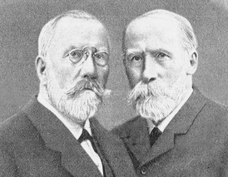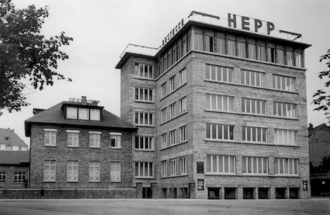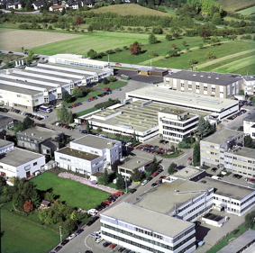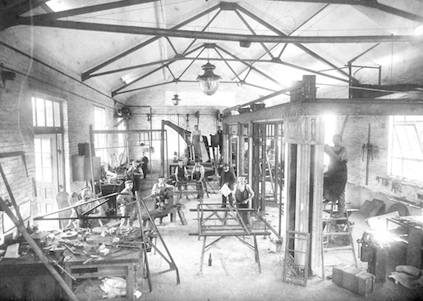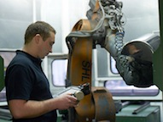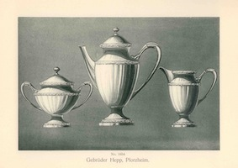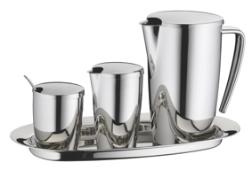

Further information:  Hepp  A brand of proHeq GmbH  Carl-Benz-Str. 10 – 75217 Birkenfeld  Tel.: +49 7231 4885-0 – Fax: +49 7231 4885-83  presse@hepp.de – www.hepp.de | Press and PR:  Press’n’Relations GmbH  Andrea Wagner  Gräßstr. 66 – D-81241 München  Tel.: 089 5404722-20 – Fax: 089 5404722-29  hepp@press-n-relations.de - www.press-n-relations.de

About Hepp
HEPP – a brand of proHeq GmbH – has its headquarters in Birkenfeld by Pforzheim and is one of the leading international providers of tableware. The company uses highly specialised manufacturing processes to produce the world's most diverse range of tableware and serving equipment – from cutlery, coffee pots and the like to chafing dishes and food distribution systems. Material and workmanship are to the fore, but the design, quality and high level of functionality of Hepp products leave nothing to be desired either. Brothers Carl and Otto Hepp founded the company back in 1863 under these premises and are therefore rightly considered the inventors of hotel silver. The traditional values of reliability and quality still apply today and form the basis for the success of the company in combination with innovative strength, the development of new processes and products and flexible manufacturing. Globally, Hepp is one of the preferred outfitters of leading hotels, hotel chains and restaurants, as well as quality-conscious major catering firms, international cruise lines, airlines and railway companies.

