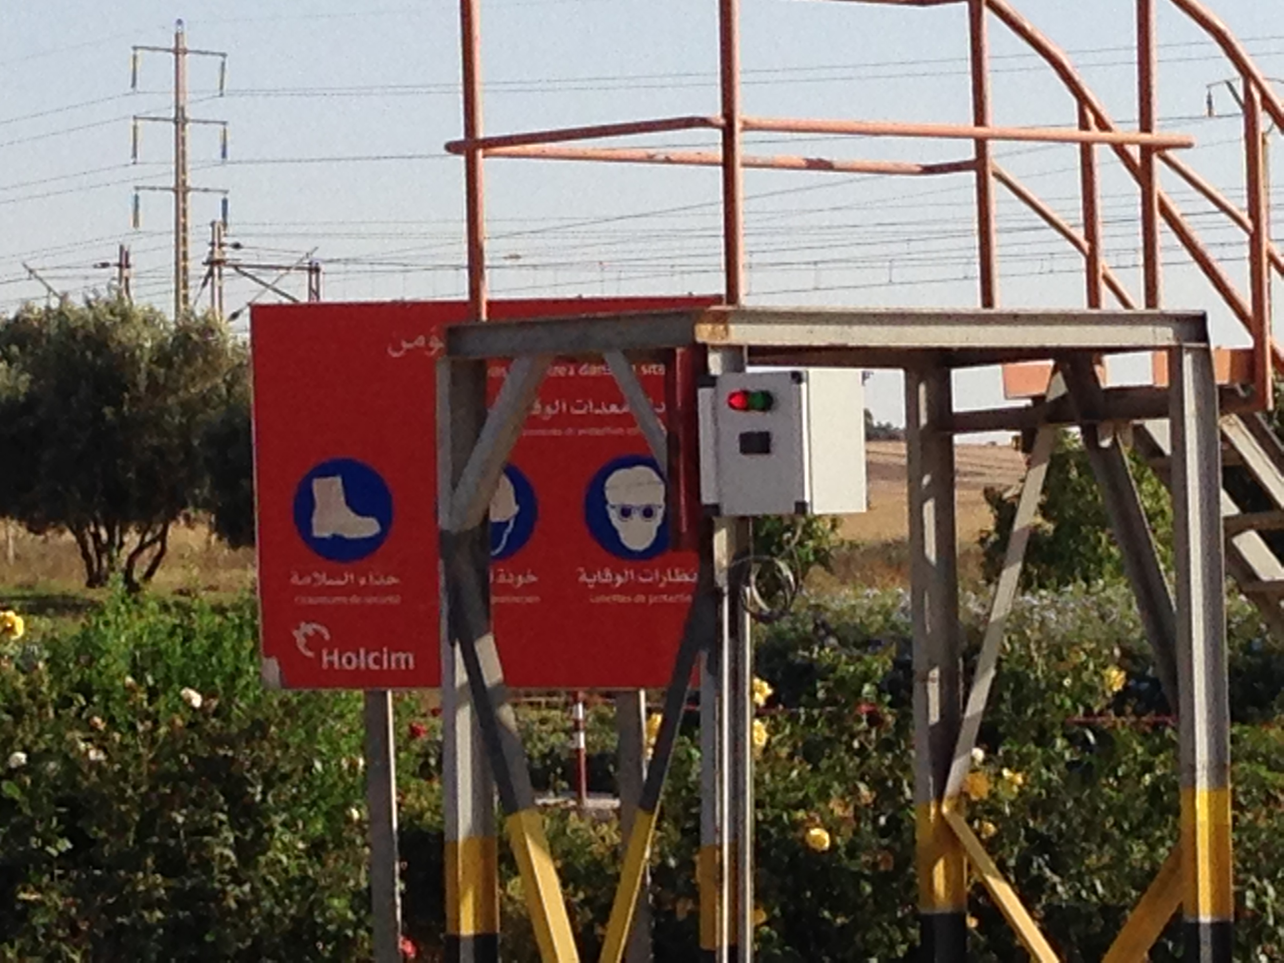
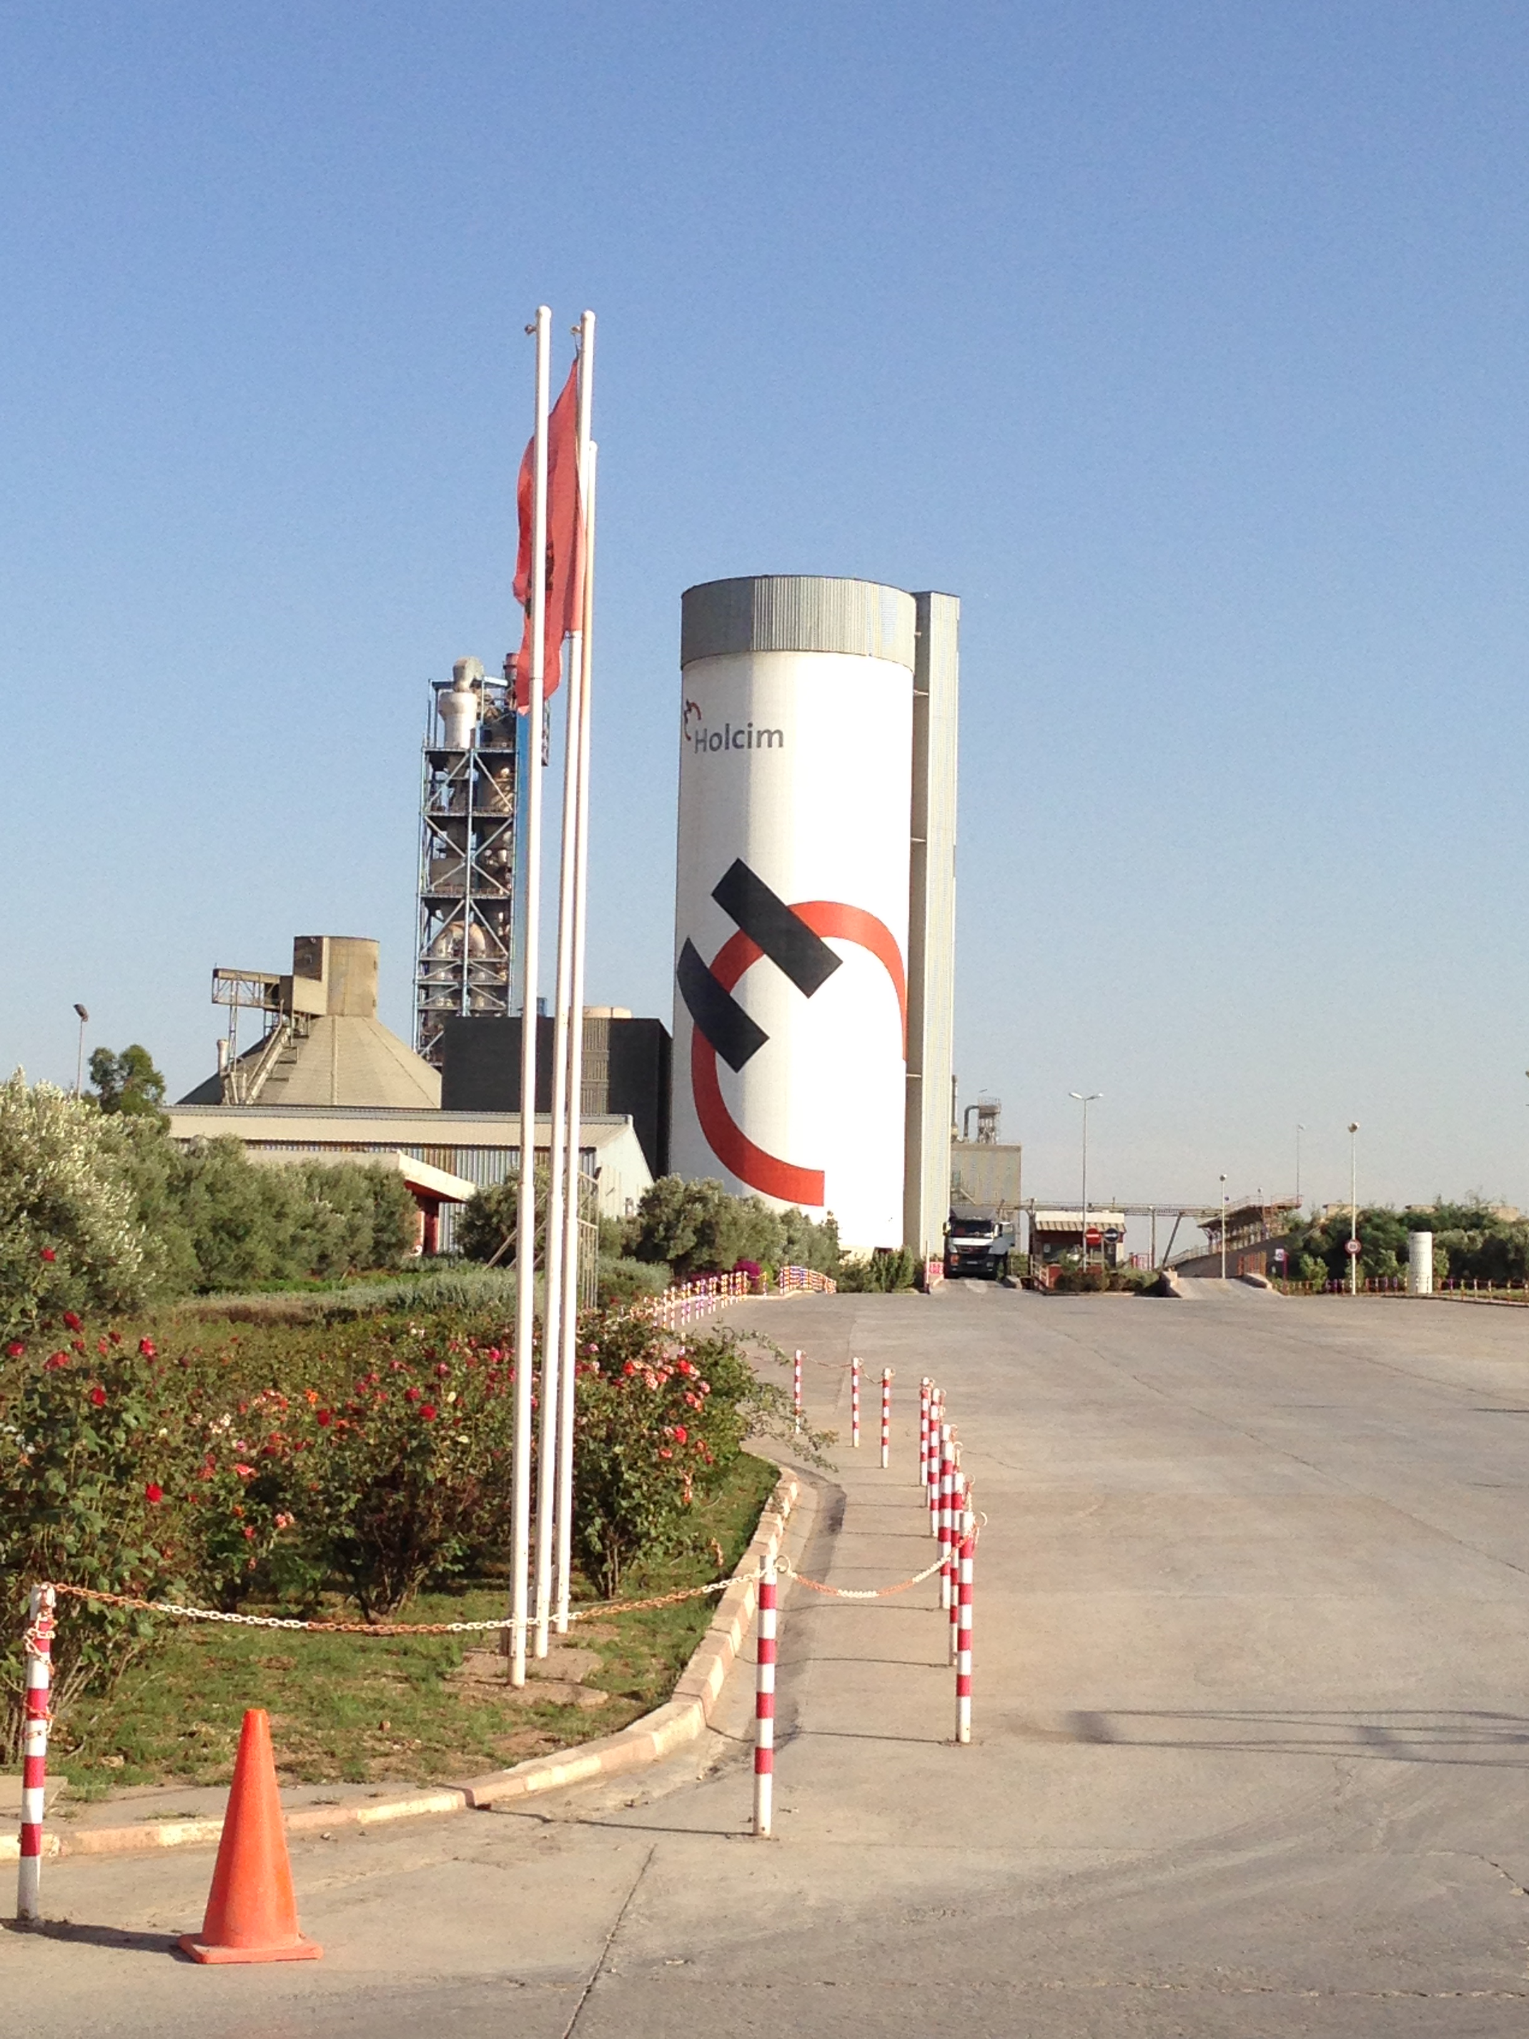

FRITZ & MACZIOL extend their Market Position in North Africa

Holcim Morocco counts on the IT-Logistic Solution VAS

After the implementation of VAS in the Holcim plants in the Philippines and Indonesia, the IT-Logistic Solution was implemented successful in Morocco by Holcim for the first time. The pilot insalltation was undertaken in the cement plant Settat, which is located between Casablanca and
Marrakesh. The project was carried out on the basis of the „Global Framework Agreement“, that Holcim and FRITZ & MACZIOL have sealed two years ago. Since June, the VAS system runs successfully. The start of production was realized in the second quarter of the current year. After the successful implementation in Settat, the Moroccon Holcim plants in Oujda, Fes and Nador are supposed to be the next plants to be equipped with VAS. Besides the software and services, FRITZ & MACZIOL delivered the full infrastructure for the project. This includes not only the IT-Hardware like printers or large displays for the control room but also barriers and signal lights for traffic control within the plant.

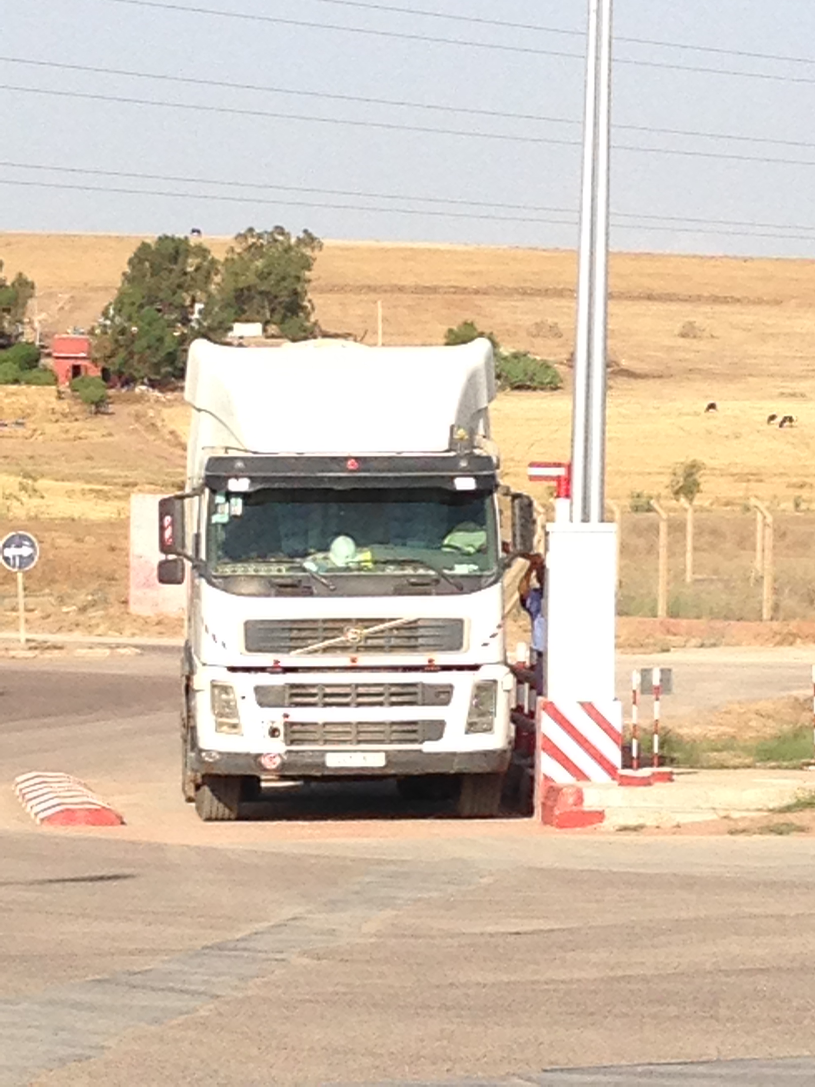
The first project step for the Settat plant led to a partial automation of the dispatch processes. The full-automation level was achieved following the completion of the second project phase including the introduction of the automated bulk loading. A VAS standard-template which FRITZ & MACZIOL has developed in conjunction with the Holcim IT
department forms the basis of the project implementation. This way the introduction of VAS is not only simplified but also accelarated as the template can also be used for remaining HOLCIM plants for example in Morocco. Furthermore, the IT- Logistic Solution works as an integrated part with the central SAP-System of Holcim.

For FRITZ & MACZIOL Holcim Morocco is already the second big customer in Morocco, as one year ago Ciments de l'Atlas CIMAT with their Headquarters in Casablanca has decided to implement VAS in their Moroccon cement plants.

About VAS
VAS – the process-orientated software solution for the raw materials industry - forms the entire process chain from delivery via dispatch and loading, right up to departure. As the link between ERP systems and technical systems, VAS represents the key function and the 'adjusting screw' for efficient process sequences. In addition, VAS supports reporting functions and supplies real-time information to further systems, for example for Production, Sales or Controlling. All external technical systems such as the weighing, silo or metering technology are completely integrated into the VAS® logistics system processes. VAS is currently used in more than 180 plants worldwide within the raw materials industry.
.

Further information:  FRITZ & MACZIOL Software  und Computervertrieb GmbH  Hörvelsinger Weg 17, D-89081 Ulm  www.fum-vas.de  Sabine Maier - Int. Sales & Marketing  Tel.: +49 (0) 731 / 1551-425  Fax: +49 (0) 731 / 1551-555  E-Mail: vas@fum.de | Press and Public Relations:  Press'n'Relations GmbH - Uwe Pagel  Magirusstr. 33 - 89077 Ulm  Tel. : +49 (0) 731 96287-29  Fax: +49 (0) 731 96287-97  E-Mail: upa@press-n-relations.de  www.press-n-relations.de

Background information
The FRITZ & MACZIOL group (F&M group) with headquarters in Ulm includes the companies FRITZ & MACZIOL Software und Computervertrieb GmbH, INFOMA® Software Consulting GmbH, FRITZ & MACZIOL Asia Inc. and IT&T AG. With more than 1,000 employees, the F&M group is positioned at 18 locations in Germany, Switzerland and Asia. There are also service offices across Europe, in the USA, Russia and Saudi Arabia. The F&M group is one of the top 10 IT companies in Germany.

Both a specialist and a generalist, the group offers an integrated portfolio of consulting, services, software, hardware and IT operations in selected fields.The companies of the F&M group develop and sell software and system solutions for public clients, medium-sized and large companies. The F&M group is a top partner to IBM, Microsoft and SAP, as well as EMC and Cisco with the highest certifications and provides customers with the full range of relevant IT subjects based on the latest technologies of these global market leaders and additional manufacturers.
Since October 2014, the F&M group has been part of the French conglomerate VINCI Energies. The German management unit, the VINCI Energies ICT Pôle with more than 1,200 IT experts, also includes Crocodial IT Security GmbH and Axians Networks & Solutions GmbH in addition to the companies of the F&M group.

Since April 2015, VINCI Energies has bundled all its global ICT activities under the umbrella of the Axians brand. The F&M group offers its customers completely new and advanced solutions via this company network – locally, but also far beyond Germany's borders.

