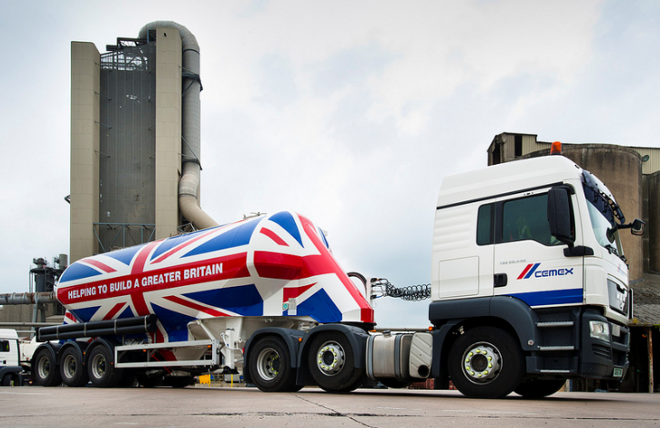

International standardisation of logistic processes

VAS WINS CEMEX CONTRACT

Ulm, 28th of October 2013. VAS® the IT-Logistics solution of the FRITZ & MACZIOL group has recently won an international bid of the renown CEMEX company.

As a multinational enterprise in the building materials industry, CEMEX will use VAS® on the basis of a tailor-made template solution that is connected to the central ERP system and likewise will be rolled out to several CEMEX plants starting in Germany. The key reason for choosing VAS® has been the ability to cover all requirements towards an IT-Logistics solution, that have been described in the detailed systems specification provided by CEMEX. The very good reputation of VAS® as a market proven IT solution has been another crucial factor in favour of FRITZ & MACZIOL. Following its development more than two decades ago, VAS® has been implemented in more than 140 plants across different industries worldwide.

At CEMEX the implementation of a VAS® workshop is currently being prepared. As Mr. Claus Jordan, the Director of Business Development and Marketing of the FRITZ & MACZIOL Industrial Applications and Services division noted, "CEMEX takes over the role of a trailblazer. At present many firms operating in the raw material sector are thinking about to standardise their global operations and logistic processes by using a template based solution in order to replace their older and often isolated systems". He sees the emergence of Web 2.0 technologies as a reason for this development, as they can be used to simplify the automation of logistic processes within different plants. He further stated that „a template based rollout reduces time, effort and costs on the customers side and as such secures a fast Return-on-Investment (RoI)“.

CEMEX is a global building materials company that provides high-quality products and reliable services to customers and communities in more than 50 countries. CEMEX has a rich history of improving the well-being of those it serves through innovative building solutions, efficiency advancements, and efforts to promote a sustainable future.

About VAS®
VAS® – the process-orientated software solution for the raw materials industry - forms the entire process chain from delivery via dispatch and loading, right up to departure. As the link between ERP systems and technical systems, VAS® represents the key function and the 'adjusting screw' for efficient process sequences. In addition, VAS® supports reporting functions and supplies real-time information to further systems, for example for Production, Sales or Controlling. All external technical systems such as the weighing, silo or metering technology are completely integrated into the VAS® logistics system processes. VAS® is currently used in more than 160 plants worldwide within the raw materials industry.

Further information:  FRITZ & MACZIOL Software  und Computervertrieb GmbH  Hörvelsinger Weg 17, D-89081 Ulm  www.fum-vas.de  Sabine Büschl  Industrial Applications & Services  Tel.: +49 (0) 731 / 1551-425  Fax: +49 (0) 731 / 1551-555  E-Mail: sbueschl@fum.de | Press and Public Relations:  Press'n'Relations GmbH - Uwe Pagel  Magirusstr. 33 - 89077 Ulm  Tel. : +49 (0) 731 96287-29  Fax: +49 (0) 731 96287-97  E-Mail: upa@press-n-relations.de  www.press-n-relations.de  CEMEX Media Relations  Jorge Pérez  +52 (81) 8888-4334  mr@cemex.com
Background information
The FRITZ & MACZIOL Group, with its Headquarters in Ulm, incorporates the companies FRITZ & MACZIOL Software and Computervertrieb GmbH, INFOMA® Software Consulting GmbH, FRITZ & MACZIOL Schweiz AG, FRITZ & MACZIOL Asia Inc. and IT&T AG. Currently employing more than 1000 people at 22 sites and six service sites worldwide, the group of companies achieved an overall turnover of over 364 million EUR in 2012.

The FRITZ & MACZIOL Group has positioned itself both in Germany and Switzerland as well as in various countries worldwide through the FRITZ & MACZIOL Asia Inc. and Service Offices. Acting as both specialist and generalist providers, the Group as a system and consultancy firm offers a holistic portfolio of hardware, software, services and consulting in selected fields. The companies within the FRITZ & MACZIOL Group develop and sell software and system solutions for public clients, small and medium-sized businesses and large-scale companies. The group of companies acts as the top partner for IBM, Microsoft and SAP as well as EMC and Cisco, with the highest certifications, and provides the customer with a complete spectrum of relevant IT topics based on the latest technologies produced by these international market leaders in addition to further manufacturers. As part of the Dutch technology concern Imtech N.V., the system and consultancy firm makes use of the Imtech ICT Division as well as cooperation partners from the other divisions, for example the German Imtech in the Data Center Division, and also European synergies.

