Ravensburg, April 12, 2017
AKASOL confirmed for Intersolar Europe / EES:
Munich, May 31 – June 2, 2017, Hall B1 / Stand 150 and 170C
Premiere: GridSense-compatible PV battery systems
neeoBASIX allows for intelligent and efficient power management in the home
At this year’s Intersolar Europe in Munich (May 31 to June 2, 2017), AKASOL will be presenting its new GridSense-compatible neeoBASIX PV storage unit for the first time. Available in two performance classes (6.5 / 13 kWh), the energy storage units detect every PV installation and all relevant power consumers in the home, and even optimize all energy flows fully automatically on the basis of learning algorithms and forecasts. “The neeoBASIX unit with GridSense provides owners of PV installations with a range of benefits: they primarily consume power that they generate themselves, and any excess electricity is delivered back to the power grid in a grid-friendly manner. This slashes energy costs and significantly reduces the payback period of the unit,” states Markus Michelberger, Head of Stationary Battery Systems at AKASOL. Intelligent and offering good scalability, the PV battery system from the “neeo by AKASOL” product range can be fitted with the optional GridSense Home Energy Management System, developed by the Zurich-based Alpiq InTec Group.
The neeoBASIX unit with GridSense is ideal for photovoltaic installations in private households and smaller businesses with peak power of 10 kWp. GridSense-compatible energy management enables all electricity producers and consumers in the building that are fitted with this technology – PV units, heat pumps, boilers, house batteries, charging stations for electric cars and so on – to be managed and interconnected, and allows the loads borne across all devices to be optimized. Based on an algorithm developed in-house, various parameters such as grid load, electricity consumption and production are continuously measured, and weather forecasts and electricity tariffs are included in the calculations. The intelligent algorithm also learns the individual behavior of the electricity consumer in question. Markus Michelberger: “Smart energy management and integrated three-phase power electronics combine to form a high-performance lithium-ion storage system. In addition, the neeoBASIX system guarantees a secure energy supply which is available over the long term. This means that the unit can actually manage the energy volume of a small micro-cogeneration plant (1-5 kW of electricity).” It is easy to set up the intelligent PV storage system: instead of extensive configuration and parameterization processes, the PV storage unit’s user-friendly Plug&Play installation option keeps installation times extremely short. The unit also eliminates the need to purchase additional cables.
Smart energy savings
The integration of Alpiq GridSense enables the AKASOL neeoBASIX to make continuous and adaptive 24-hour energy forecasts for each device and maintain comfort limits for hot water, heating, electric cars, etc. The basic parameters of each device are monitored, which can, for example, allow for dynamic control due to photovoltaic production instead of having to rely on fixed switch-on and switch-off times. This dynamic control adapts in a flexible manner to unforeseen developments such as holidays or absences, and to the various times of the year (seasons in which heating is used, etc.). The PV storage units (which can be controlled via an app) also integrate variable energy tariffs – such as for residual current cover – and take into account both weather forecasts (global radiation, temperature) and non-manageable consumption, e.g. in the case of cooking/baking or when using a dishwasher or washing machine. Another advantage is that the neeoBASIX unit delivers excess energy back to the grid in a ‘grid-friendly’ manner, thereby reducing the burden on the distribution network by up to 50 percent.
E-mobility by AKASOL
AKASOL will offer an insight into the mobile utilization of high-performance battery systems at E-Mobility & Renewable Energy, a special fair organized by ees Europe (stand B1.170C). Visitors to the fair can learn more about the liquid-cooled battery system AKASystem AKM, which is used in buses, trains and ships. Depending on requirements, the system provides a powerful, consistent supply of energy required for keeping the vehicle mobile on the street, railway tracks or water in a sustainable manner.

neeoBASIX (GridSense) – technical data
Battery inverter | neeoBASIX 6.5 | neeoBASIX 13
AC values
System capacity AC max. / peak | 2.6 kW / 3 kW
Grid connection | 400 V, three-phase, 50 Hz
Electrical connection | 3L / N / PE
Nominal frequency / nominal frequency range | 50 Hz (47.5 ... 51.5 Hz)
Efficiency of loading/unloading | > 93.5 %
AC short circuit protection | Yes
AC overload protection | Yes
Abnormal temperature protection | Yes
Power factor | 0.95 (capacitative) ... 1 ... 0.95 (inductive)
DC values
Max. discharge current | 50 A | 60 A
Max. charging current | 45 A | 45 A
DC voltage range | 42 V to 100 V
Max. charging capacity (DC) | 2.3 kW
Max. discharge capacity | 3 kW
Battery module
Battery capacity (nominal energy) | 6.5 kWh | 13 kWh
Usable energy (DC) | 5.5 kWh | 11 kWh
Cell technology +/- | Lithium (NMC / graphite)
Nominal voltage | 51.8 V
Voltage range (discharge / charging voltage) | 42 V to 58.8 V
Anticipated full cycles | 5,000
Current market value guarantee | 10 years
Energy management and data
Communication for available grid infrastructure | Ethernet
Visualization | Standard web browser, portal
Security | Authentication, hierarchy of access rights
Internal data memory | 4 GB
PV inverter for output reduction | 1 relay (closing contact, max. load 24V/5A)
General data
Ambient temperature values | +5°C and +30°C
Dimensions (H x W x D) | 775 x 560 x 640 mm
Weight | 133 kg | 176 kg
Height (altitude) above sea level | < 2,000 m
Protection class | IP21
Total consumption in standby mode | 27 W
A generation and consumption meter calibrated to the system is included with the delivery.

Images

The latest model from the neeo by AKASOL product series: the AKASOL neeoBASIX PV battery system with GridSense. (Photo: AKASOL)
AKA_neeoBASIX_MM_2017.jpg
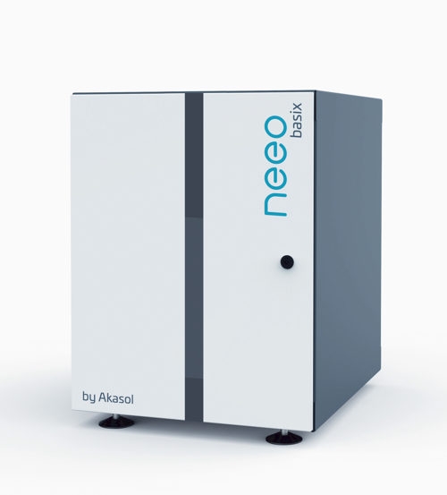

Further information  AKASOL GmbH, Katja Steinhauser  Landwehrstraße 55, 64293 Darmstadt, Germany  phone.: +49 6151 80 05 00-140  fax: +49 6151 80 08 00-129  katja.steinhauser@akasol.com  www.akasol.com | Press and public relations:  Press’n’Relations GmbH, Uwe Taeger  Magirusstraße 33, 89077 Ulm, Germany  phone.: +49 731 96 287-31  fax: +49 731 96 287-97  ut@press-n-relations.de  www.press-n-relations.de
About AKASOL
AKASOL GmbH has developed and manufactured mobile and stationary high-performance battery systems for the German and European market for 25 years. Its multi-award-winning storage solutions are used primarily in the automotive and commercial vehicle industries, the off-highway industry, and the solar power and wind power sectors.

